

Fundamentals of Programming

ME-15

Section B

1st Semester

Date of Submission: 11/10/2023

Haniyyah Abbas 481755

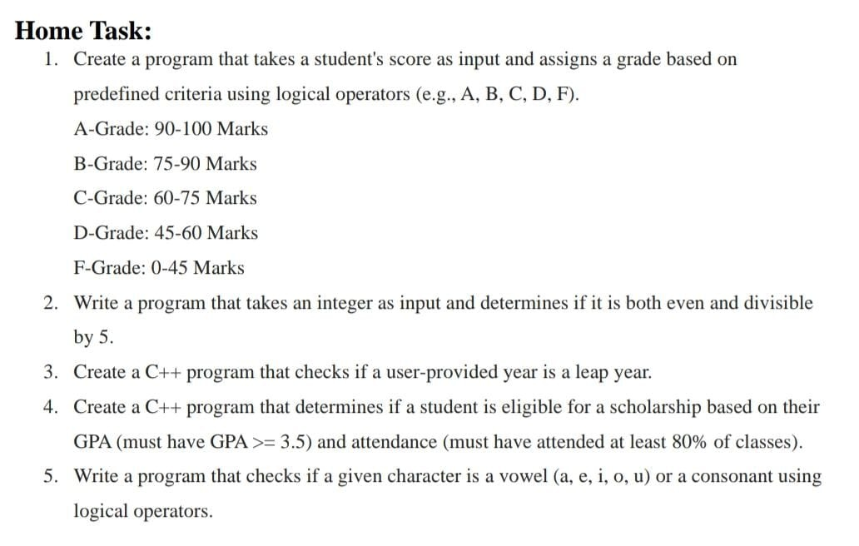

**TASK 1**

**# include <iostream>**

**using namespace std;**

int main() {

int number;

cout<<"Enter score:"<<endl;

cin>>number;

if (number>=90 && number<=100){

cout<<"A";} **//using ‘&&’ because both the statements are true**

else if (number<90 && number>=75){

cout<<"B";} **//using else if because if the previous statement is wrong it’ll move on to the next one**

else if (number<75 && number>=60){

cout<<"C";}

else if (number<60 && number>=45){

cout<<"D";}

else {

cout<<"F";} **//in the end when none of the statements are true, the grade is ‘F’**

return 0;}

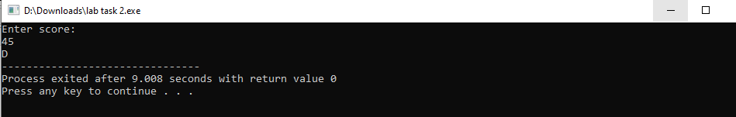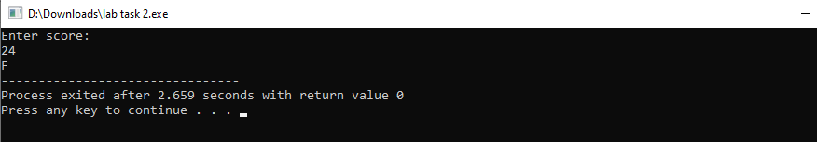**OUTPUT:**

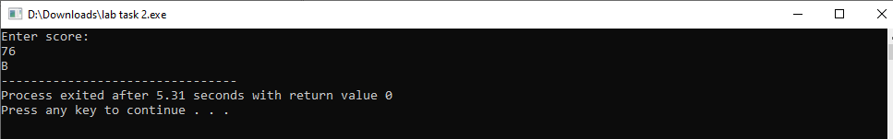

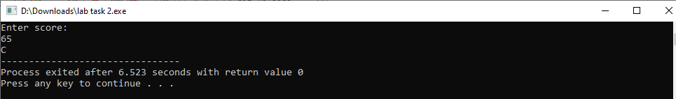

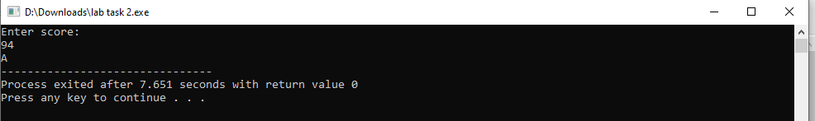

**TASK 2**

int main(){

int num1, num2 = 5, num3 = 2;

cout<<"Enter a number"<<endl;

cin>>num1;

if (num1 % num2 == 0 && num1 % num3 == 0){

cout<<"Number is even and divisible by five"<<endl;} **/* used % because for a number to be divisible by another number it has to have a remainder of zero and % tells the remainder after the division of two numbers */**

else if (num1 % num2 != 0 && num1 % num3 == 0){

cout<<"Number is even but NOT divisible by five"<<endl;} **/* the ‘!=’ tells us that the remainder is not equal to zero when the user inputs a number */**

else if (num1 % num2 == 0 && num1 % num3 != 0){

cout<<"Number is NOT even but is divisible by five"<<endl;}

else {

cout<<"Number is not even nor divisible by five"<<endl;}

return 0;

}

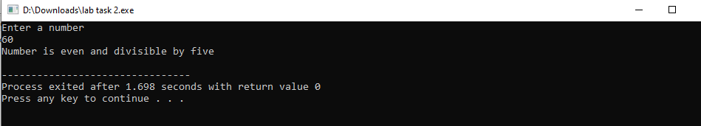**OUTPUT:**

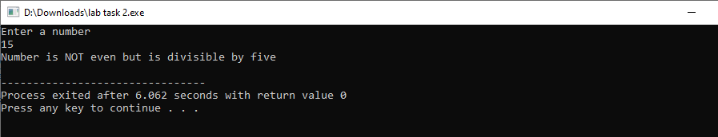

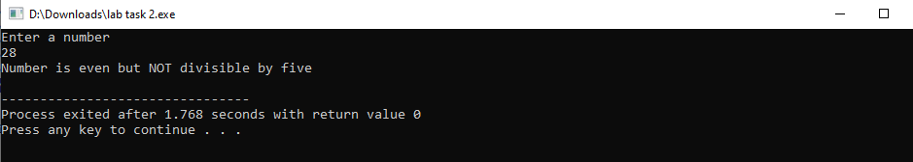

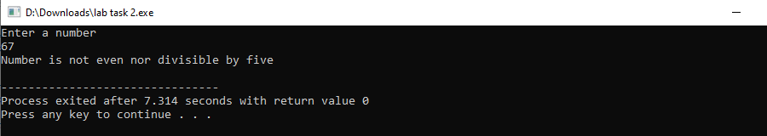

**TASK 3**

int main( ){

int year, number = 4;

cout<<"Enter a year:"<<endl;

cin>>year;

if ( year % number == 0 ){

cout<<"Year is a leap year:"<<endl;} **/* leap years are divisible by 4 so the number has to have a remainder of zero when divided by 4 */**

else {

cout<<"Year is not a leap year"<<endl;}

return 0;

}

**OUTPUT:**

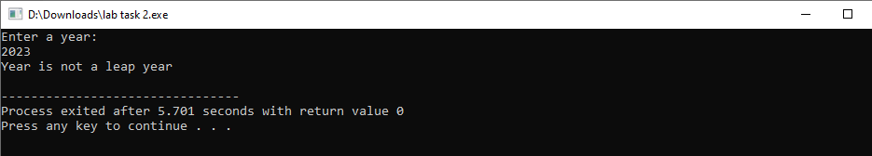

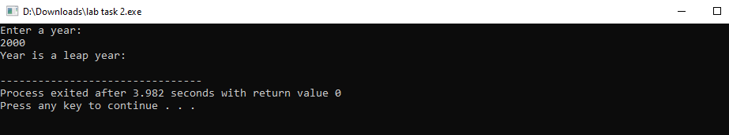

**TASK 4**

int main(){

float GPA, attendance;

cout<<"Grade Point Average:"<<endl;

cin>>GPA;

cout<<"Student Attendance Percentage:"<<endl;

cin>>attendance;

if (GPA >= 3.5 && attendance >= 80){

cout<<"Eligible for scholarship"<<endl;} **/* both GPA and attendance are required in order to print "Eligible for scholarship” or “Not eligible for scholarship” so that’s why && was used */**

else {

cout<<"Not eligible for scholarship"<<endl;}

return 0;

}

**OUTPUT:**

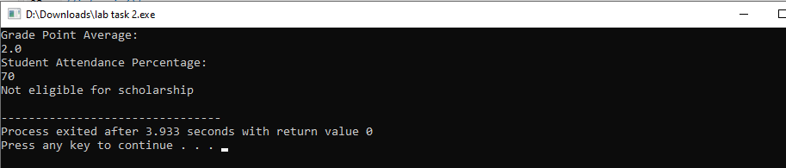

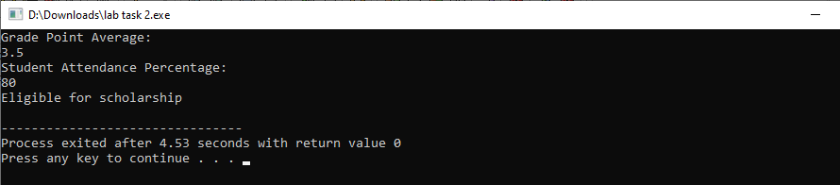

**TASK 5**

int main(){

char letter;

cout<<"Enter letter:"<<endl;

cin>>letter;

if (letter == 'a' || letter == 'i' || letter == 'e' || letter == 'u' || letter == 'o'){

cout<<"Letter is a vowel"<<endl;} **/* used || to show that ‘a’ OR ‘i’ OR etc. can be the letters the user inputs and they are vowels */**

else {

cout<<"Letter is a consonant"<<endl;} **//any letter besides the vowels is a consonant**

return 0;

}

**OUTPUT:**

